Software Architecture Diagram Examples

No standard versions as you can see – you can pick one of these or build your own.

Boxes represent components

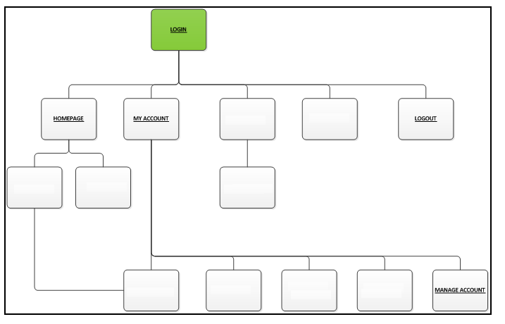

Blue boxes would represent programs in the system

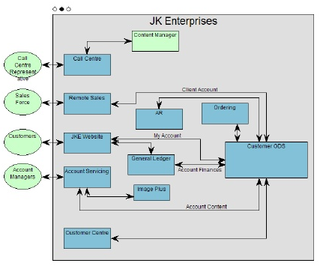

Grey boxes represent components/programs/interfaces

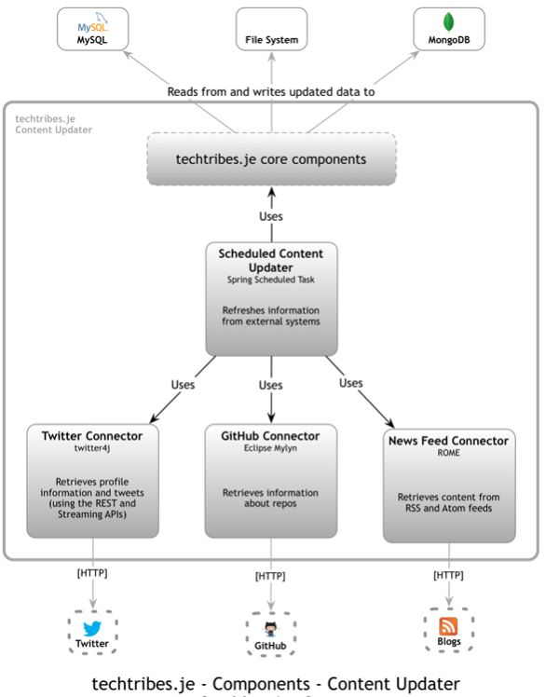

Componets based on selecting icons/buttons

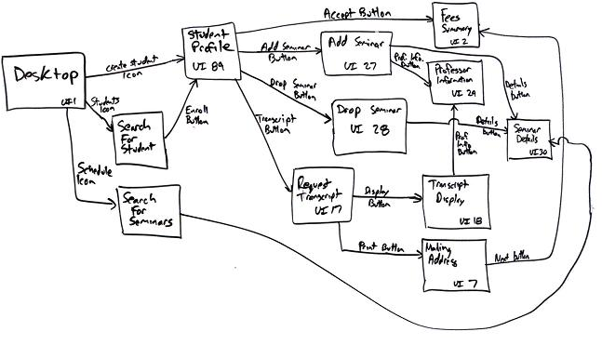

Rectangles represent components

